**Topics: Descriptive Statistics and Probability**

1. Look at the data given below. Plot the data, find the outliers and find out $μ, σ, σ^{2}$

|  |  |
| --- | --- |
| **Name of company** | **Measure X** |
| Allied Signal | 24.23% |
| Bankers Trust | 25.53% |
| General Mills | 25.41% |
| ITT Industries | 24.14% |
| J.P.Morgan & Co. | 29.62% |
| Lehman Brothers | 28.25% |
| Marriott | 25.81% |
| MCI | 24.39% |
| Merrill Lynch | 40.26% |
| Microsoft | 32.95% |
| Morgan Stanley | 91.36% |
| Sun Microsystems | 25.99% |
| Travelers | 39.42% |
| US Airways | 26.71% |
| Warner-Lambert | 35.00% |

**Ans:**

**Mean $μ$**  **= 33.27%**

**Variance $σ^{2}$**  **= 0.0287**

**Standard Deviation $σ$**  **= 0.1694**

**Outliers = 91.36%**

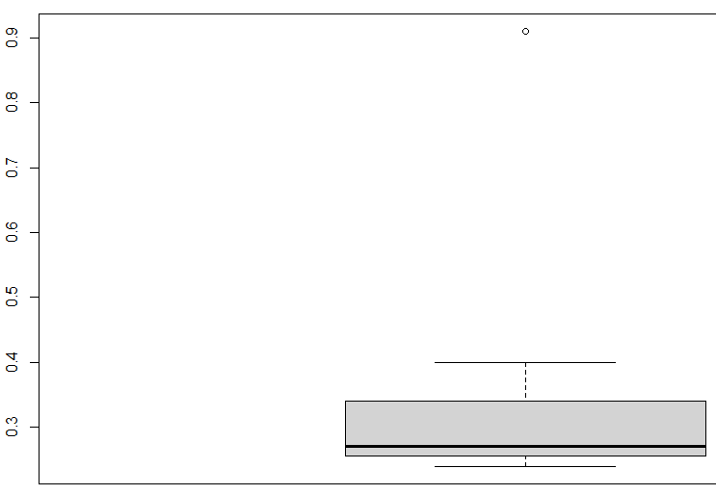



Answer the following three questions based on the box-plot above.

1. What is inter-quartile range of this dataset? (please approximate the numbers) In one line, explain what this value implies.

**Ans: IQR = 12-5 = 7. This means that 50% of the data lies within 5 and 12**

1. What can we say about the skewness of this dataset?

**Ans: The data is right skewed.**

1. If it was found that the data point with the value 25 is actually 2.5, how would the new box-plot be affected?

**Ans: There would be no outliers in the data. Whether the median shifts or not depends on the size of the data.**

**It will reduce the right skewness of the data.**



Answer the following three questions based on the histogram above.

1. Where would the mode of this dataset lie?

**Ans; The mode can lie between 4 and 10 because there are many values in this range but this is just an assumption.**

1. Comment on the skewness of the dataset.

**Ans: The data distribution is Right / Positively Skewed.**

1. Suppose that the above histogram and the box-plot in question 2 are plotted for the same dataset. Explain how these graphs complement each other in providing information about any dataset.

**Ans:**

**Both the data sets are Right Skewed.**

**Both datasets have one outlier which is 25.**

1. AT&T was running commercials in 1990 aimed at luring back customers who had switched to one of the other long-distance phone service providers. One such commercial shows a businessman trying to reach Phoenix and mistakenly getting Fiji, where a half-naked native on a beach responds incomprehensibly in Polynesian. When asked about this advertisement, AT&T admitted that the portrayed incident did not actually take place but added that this was an enactment of something that “could happen.” Suppose that one in 200 long-distance telephone calls is misdirected. What is the probability that at least one in five attempted telephone calls reaches the wrong number? (Assume independence of attempts.)

**Ans:**

**Probability of one misdirected call among 200**

**P(mc) = 1/200 = 0.005**

**Probability of not wrong call: 1 - P(mc) =1- 1/200 = 0.995**

**Probability of at least one out of five is a wrong number**

**= 1 – Probability that all five calls are not wrong numbers**

**= 1 – (1 – P(mc))^5**

**= 1 – (1- 0.005)^5**

**0.02475 or 2.475%**

1. Returns on a certain business venture, to the nearest $1,000, are known to follow the following probability distribution

|  |  |
| --- | --- |
| x | P(x) |
| -2,000 | 0.1 |
| -1,000 | 0.1 |
| 0 | 0.2 |
| 1000 | 0.2 |
| 2000 | 0.3 |
| 3000 | 0.1 |

1. What is the most likely monetary outcome of the business venture?

**Ans: $2000 has highest probability of 30%**

1. Is the venture likely to be successful? Explain

**Ans: based on the data provided, we can look at positive returns as a measure of success. The probability distribution gives us an idea about the long-term chances of earning given values of returns (indicated by x). therefore, there is a 60% probability that the venture would be successful. (Note: 0.2+0.3+0.1=0.6=>0.6*100=>60%)**

1. What is the long-term average earning of business ventures of this kind? Explain

**Ans: Expected Value (Long Term Average) = $800**

1. What is the good measure of the risk involved in a venture of this kind? Compute this measure

**Ans:**

**Standard Deviation = 1870.83  
The large value of standard deviation of $1870 is considered along with the average returns of $800 indicates that this venture is highly risky.**